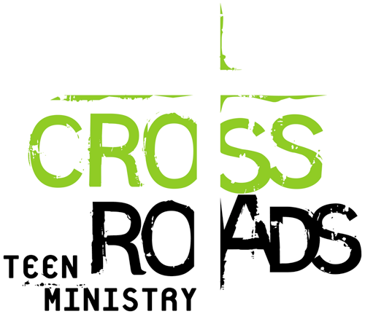
FALL SCHEDULE
(Fall) 2016
31 August Teachers meeting (Wednesday)
3 September Baptism, communion
7 September Teacher meeting (Wednesday)
11 September Opening service of Crossroads Teen Ministry
Service in the Main Sanctuary
18 September Lesson/ Parents meeting
23–25 September Trip to Elim
25 September Lesson

2 October Lesson
9 October Review lessons and Potluck/ 1:00pm – Home Visit
14-16 October Trip to Elim
16 October Lesson
23 October Teen serves (Youth Hall)
30 October Discussion for all students (Youth Hall)

6 November Lesson/ 1:00pm – Home Visit
11-13 November Trip to Elim
13 November Inspire Youth Conference BBS
20 November Service in the Main Sanctuary (No class)
24 November Thanksgiving Day
27 November No class

4 December Lesson
9-11 December Trip to Elim
11 December Review lessons and Christmas Party
17 December Christmas party for teachers in Youth Hall
18 December Caroling
25 December Christmas service in the Main Sanctuary/ NO CLASS
31 December New Year Serves 10:00 pm

Important dates

- 24-26 March Crossroads Teen Ministry Conference
- 28-29 April Teacher Conference (Tacoma)

