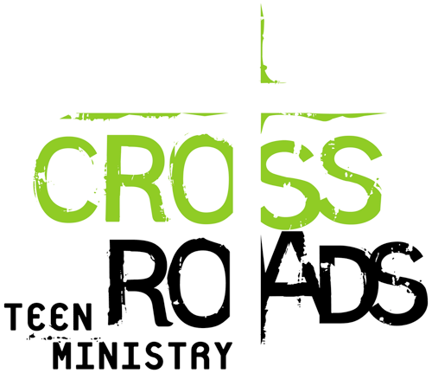
SPRING SCHEDULE
(Spring) 2017
15 January Lesson
22 January Service in the Main Sanctuary (NO CLASS)
29 January Lesson

5 February Lesson
12 February Review lessons and Potluck
17-19 February Trip to Elim (Natalia Vovk group)
19 February Lesson
24-26 February Teen Conference

5 March Lesson
10-12 March Trip to Elim (Natalia Vovk group)
12 March Lesson
18 March Rehab Center (Journey)
19 March Teen Service (Youth hall)/ NO CLASS
26 March Youth Conference BBS/ NO CLASS

2 April Review lessons and Potluck
9 April Bible Competition (Artur Nikityuk)
16 April Easter (NO CLASS)
21- 23 April Trip to Elim (Journey/girls)
23 April Lesson
28-30 April Teachers Conference (Tacoma) NO CLASS

5-7 May Trip to Elim (Journey/boys)
7 May Baptism & Communion
14 May Mother’s Day - Service in the Main Sanctuary (NO CLASS)
21 May Closing Service / Graduation (Youth Hall # 1)
27 May Youth Conference

15-19 June Prayer Camp

